# **Intimate Partner Violence: Record of Assessment and Disclosure (E6)**

**Purpose and Background**The purpose of this form is to record clinical assessment activities and client responses regarding Intimate Partner Violence (IPV) experiences, as well as nurse actions following her/his assessment. It is designed to collect data on IPV so that collated data can be analysed to identify patterns, trends and impacts over time.

Family nurses are advised to read the Intimate Partner Violence Assessment and disclosure full clinical guidance document which can be found on [FNP Online](http://familynursepartnership.ning.com/page/dv-and-ipv).

**General Guidelines**  
This form is completed for all clients at these time points: The initial view of the IPV form screen appears as below. This provides each time point for form completion and well as the green highlighted box at the bottom right of the screen which allows an unscheduled/ad hoc form to be created.

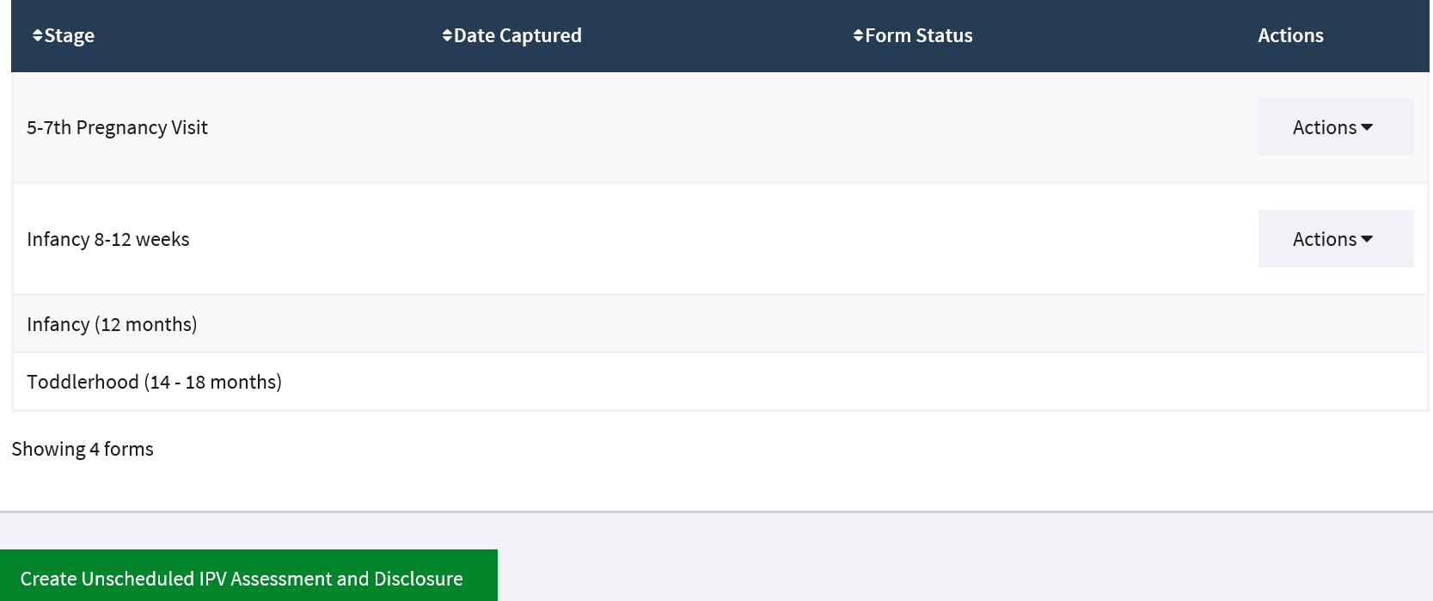

This form is to be completed by the family nurse **FOLLOWING** the visit where the “My Experiences” facilitator is used **AND** following any other visit when IPV is disclosed.

This form is not an assessment or nursing documentation form and should **NOT** be used with the client.

The form is also used to record client disclosures (current or within the last 12 months) that occur at time points outside the regular assessment points.

The form can be completed over 6 weeks to provide adequate time for the family nurse to complete the necessary follow-up activities after the initial assessment.

As with all other FNP assessment and data forms, clients should: be aware that this data is being inputted into an information system; and understand the various levels of access that others will have to this data. National and local policy and procedure should be followed to ensure that sensitive client data, such as that contained within this form, is stored securely.

**Definitions/Directions for Completing Form**The form requests that the family nurse provides information/ data on the clinical assessment that she has completed with the client. Specific instructions relating to this are as follows:

**Date of IPV assessment**The date inserted into the form should be that when the “My Experiences” facilitator was shared with the client, or the date at which IPV was spontaneously disclosed.

There are skip logic instructions on some items in this data form. The skip pattern directs the family nurse to omit a question or sequence of questions, depending upon the client’s response to a question.

For those family nurses completing paper copies of the data forms **CAREFULLY FOLLOW ALL SKIP INSTRUCTIONS** to avoid asking questions which are not relevant for the client.

For family nurses using electronic forms, the system will automatically navigate the skip patterns as you complete the form.

Failure to follow skip patterns results in data quality problems that will need to be resolved. If you discover that you have omitted a question, call the client to obtain the information or plan to return to it during the next home visit.

At all times it is essential to take appropriate measures to safeguard any paper forms against loss or theft.

***Section 1***

The family nurse should complete form items DA1, DA2 and DA3. DA1 refers to IPV experiences prior to joining the FNP programme. This question should only be completed on the first scheduled assessment in pregnancy.

Item DA3a will only appear if item DA3 is marked ‘No’.

Item DA4 only appears if ‘Yes’ is marked to item DA1.

It is important to record the client’s responses to the assessment of her IPV experiences.

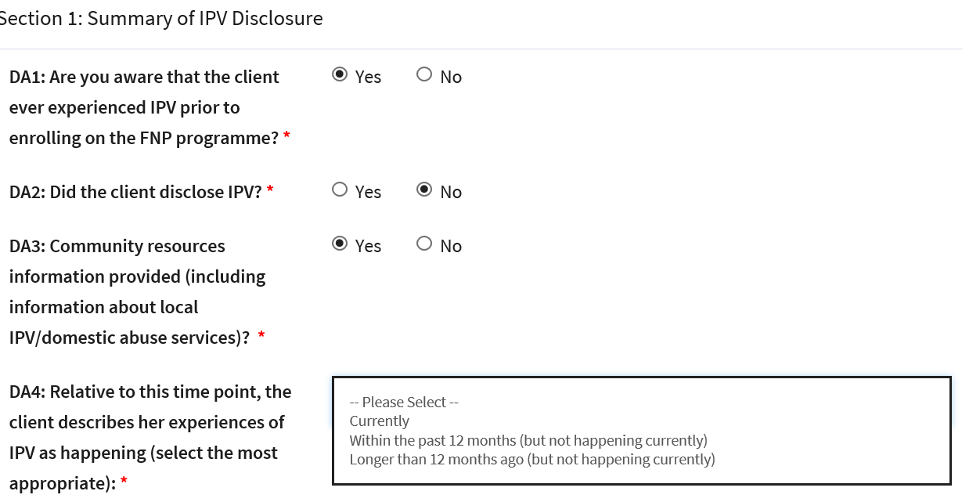

***Section 2***

This section only appears if ‘Currently’ is marked to form item DA4 indicating that the client is experiencing IPV at the time of form completion.

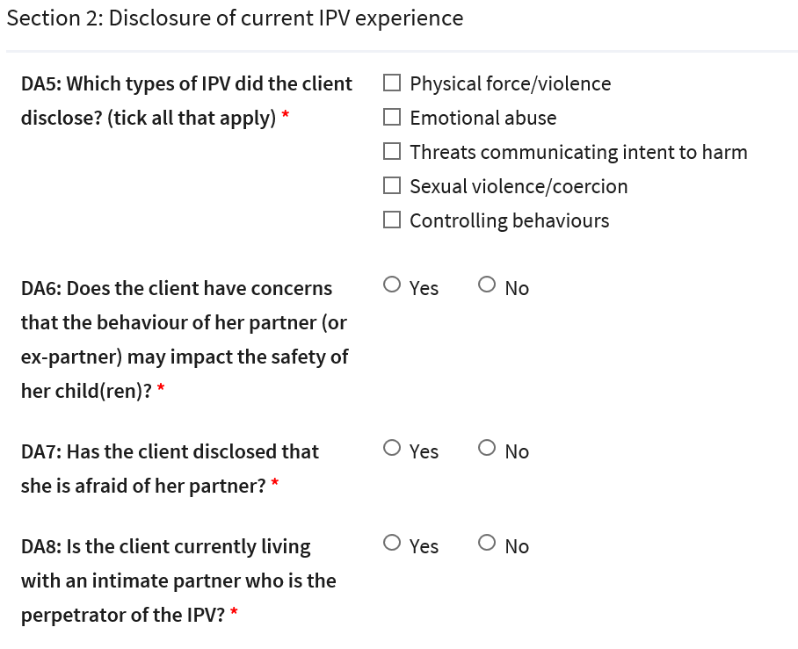

***Section 3***

This form section only appears if the response to item DA4 indicates that the client reports previous IPV.

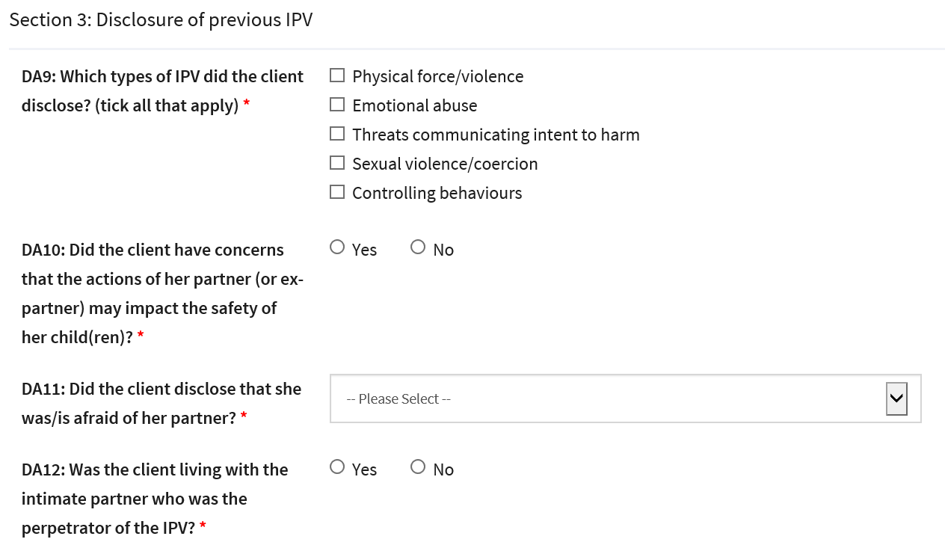

***Section 4***

If the client disclosed current IPV, or IPV within the past 12 months then complete section 4.

If the client disclosed IPV longer than 12 months ago (but not happening currently), no further sections are required.

Item DA13 should always be completed to indicate whether the nurse is undertaking any ongoing actions related to IPV at this time point.

If the answer is ‘No’, no further documentation is required on that section.

If DA 13 is marked ‘Yes’, the family nurse is to complete the remainder of the section.  
 